Name: Athulya T S

REG NO: 727721EUIT018

CLASS: IT-A

EMAIL-ID: [727721euit018@skcet.ac.in](mailto:727721euit018@skcet.ac.in)

CC-1

Q.1

Go to EC2 console🡪change region to US East-1-North Virginia🡪launch instance

Give name of instance as ec2usecase1

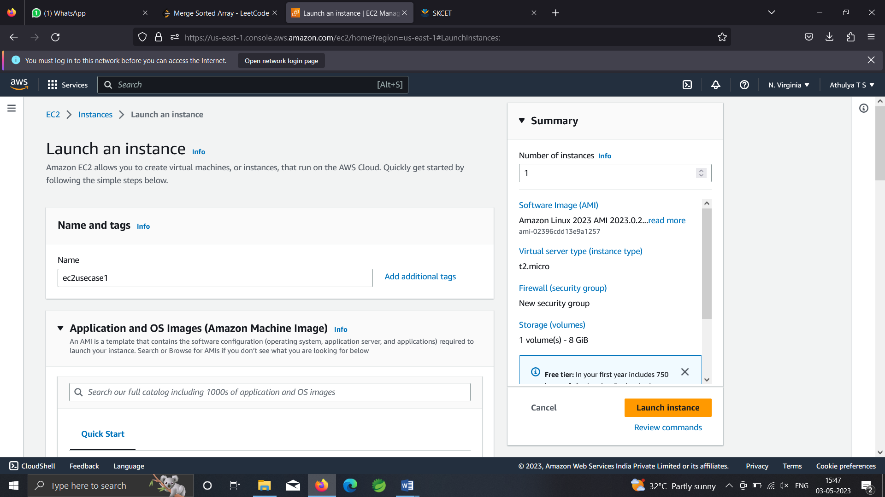 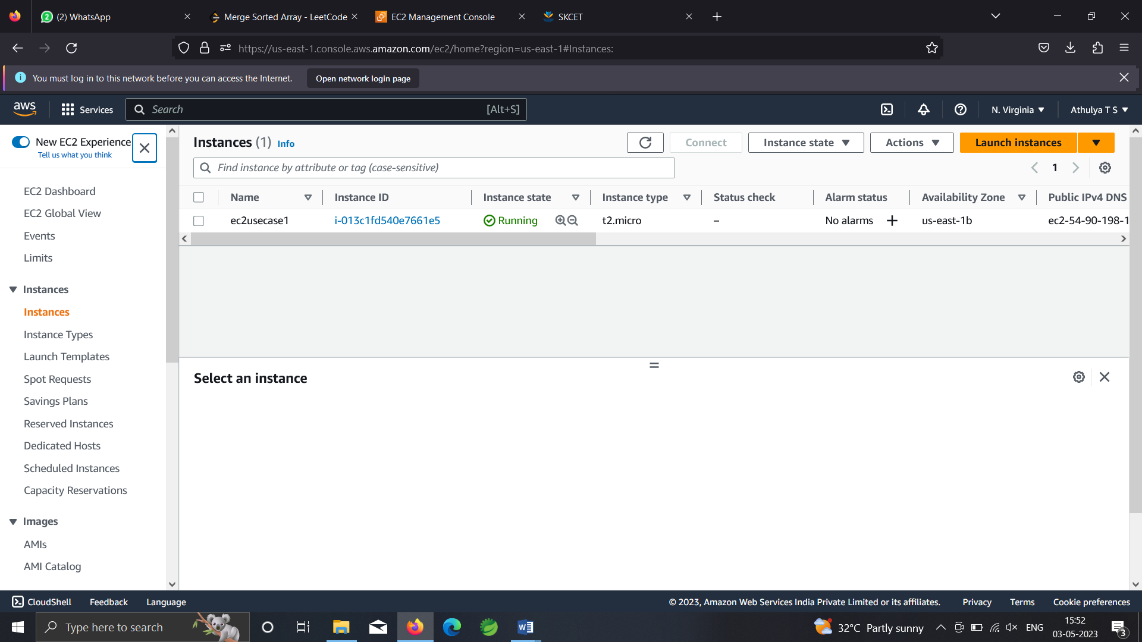

Create keypair with ec2usecase1

Select key pair file format as ppk

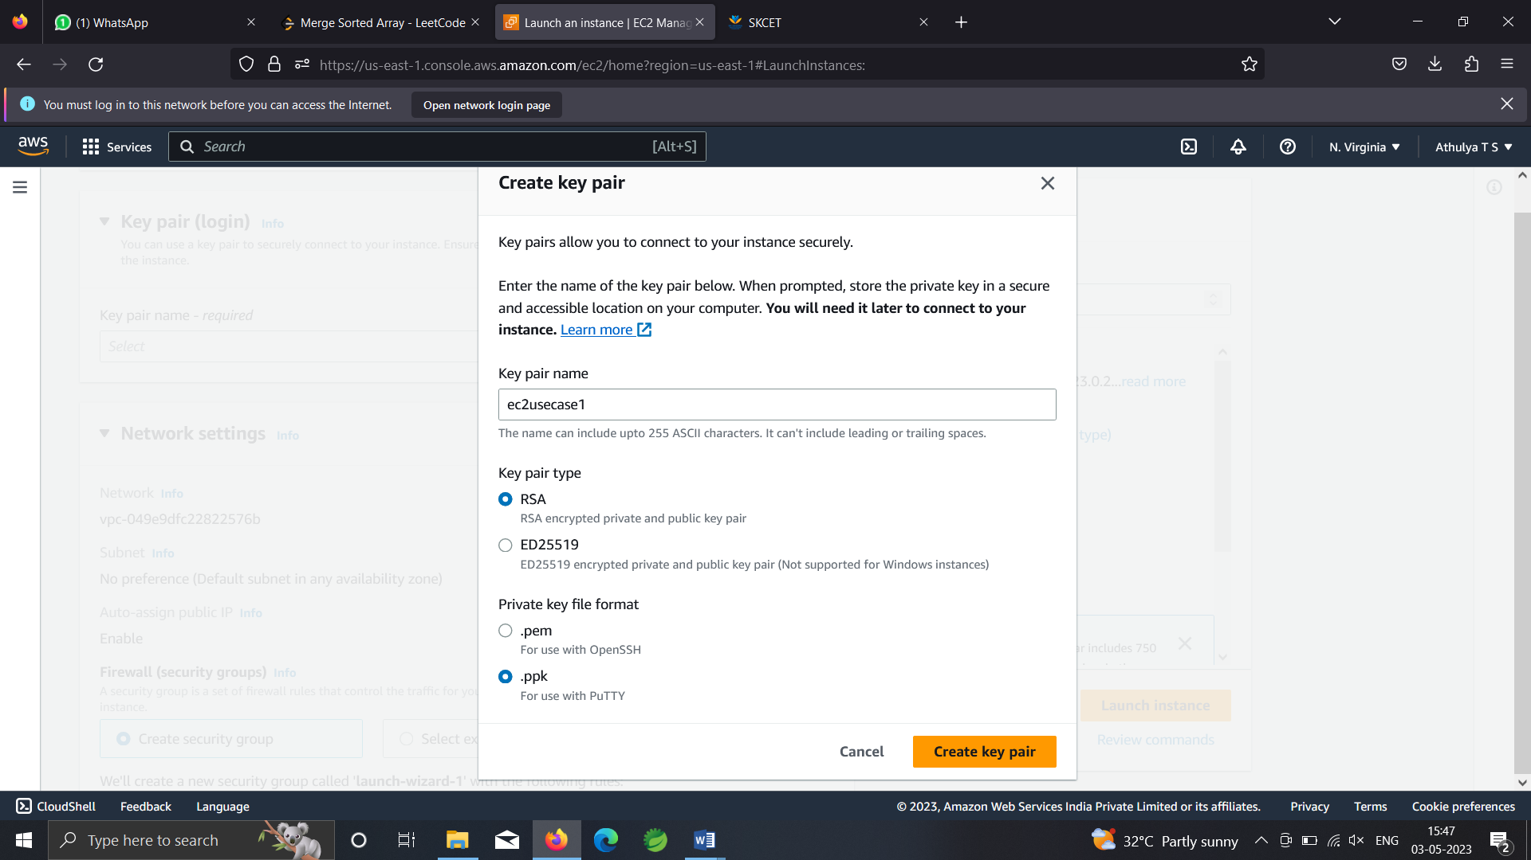 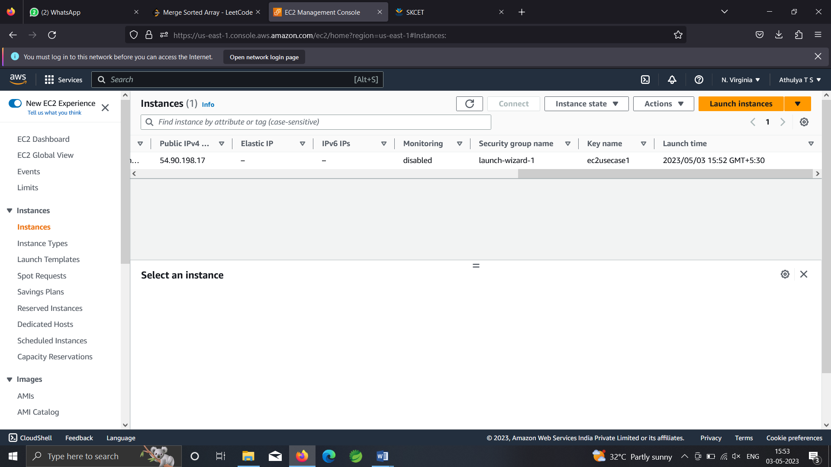

For linux 2023 ami

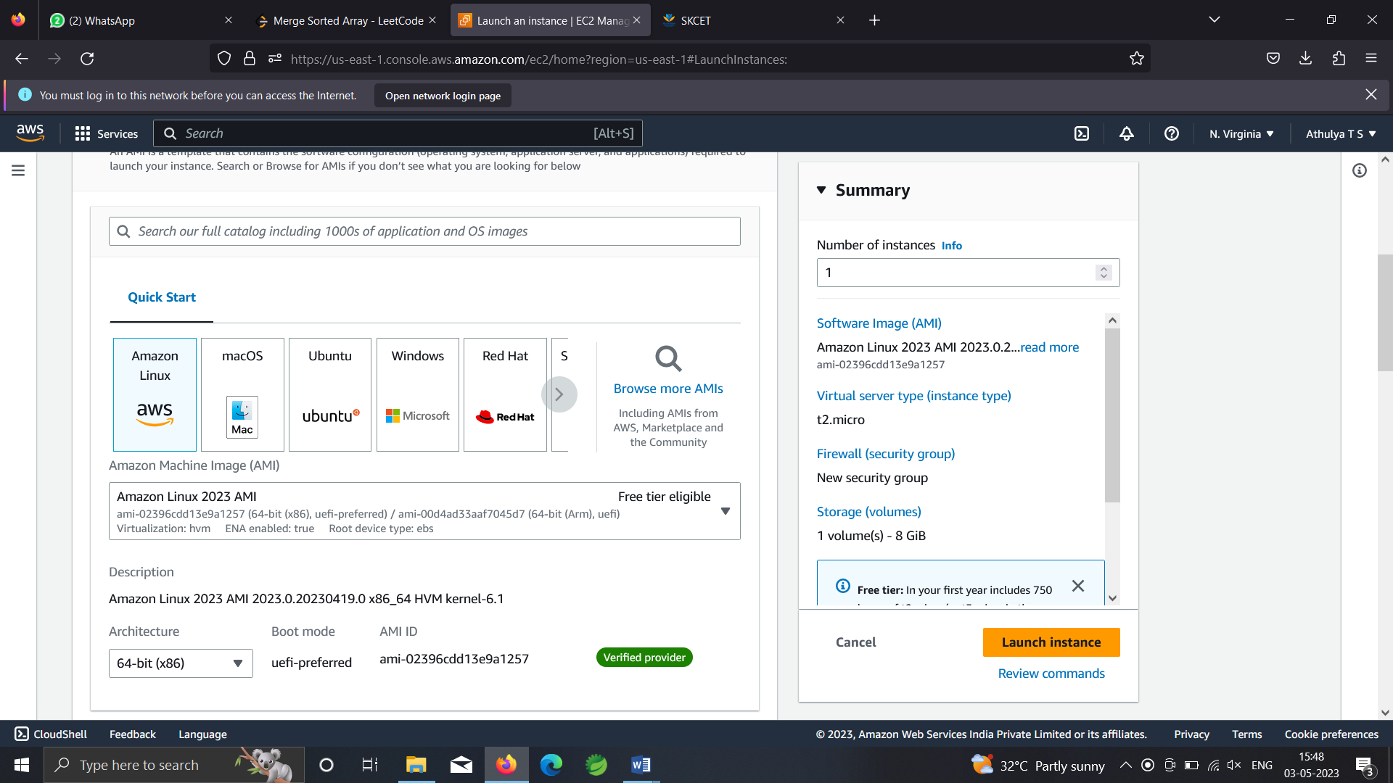

For linux 2 AMI

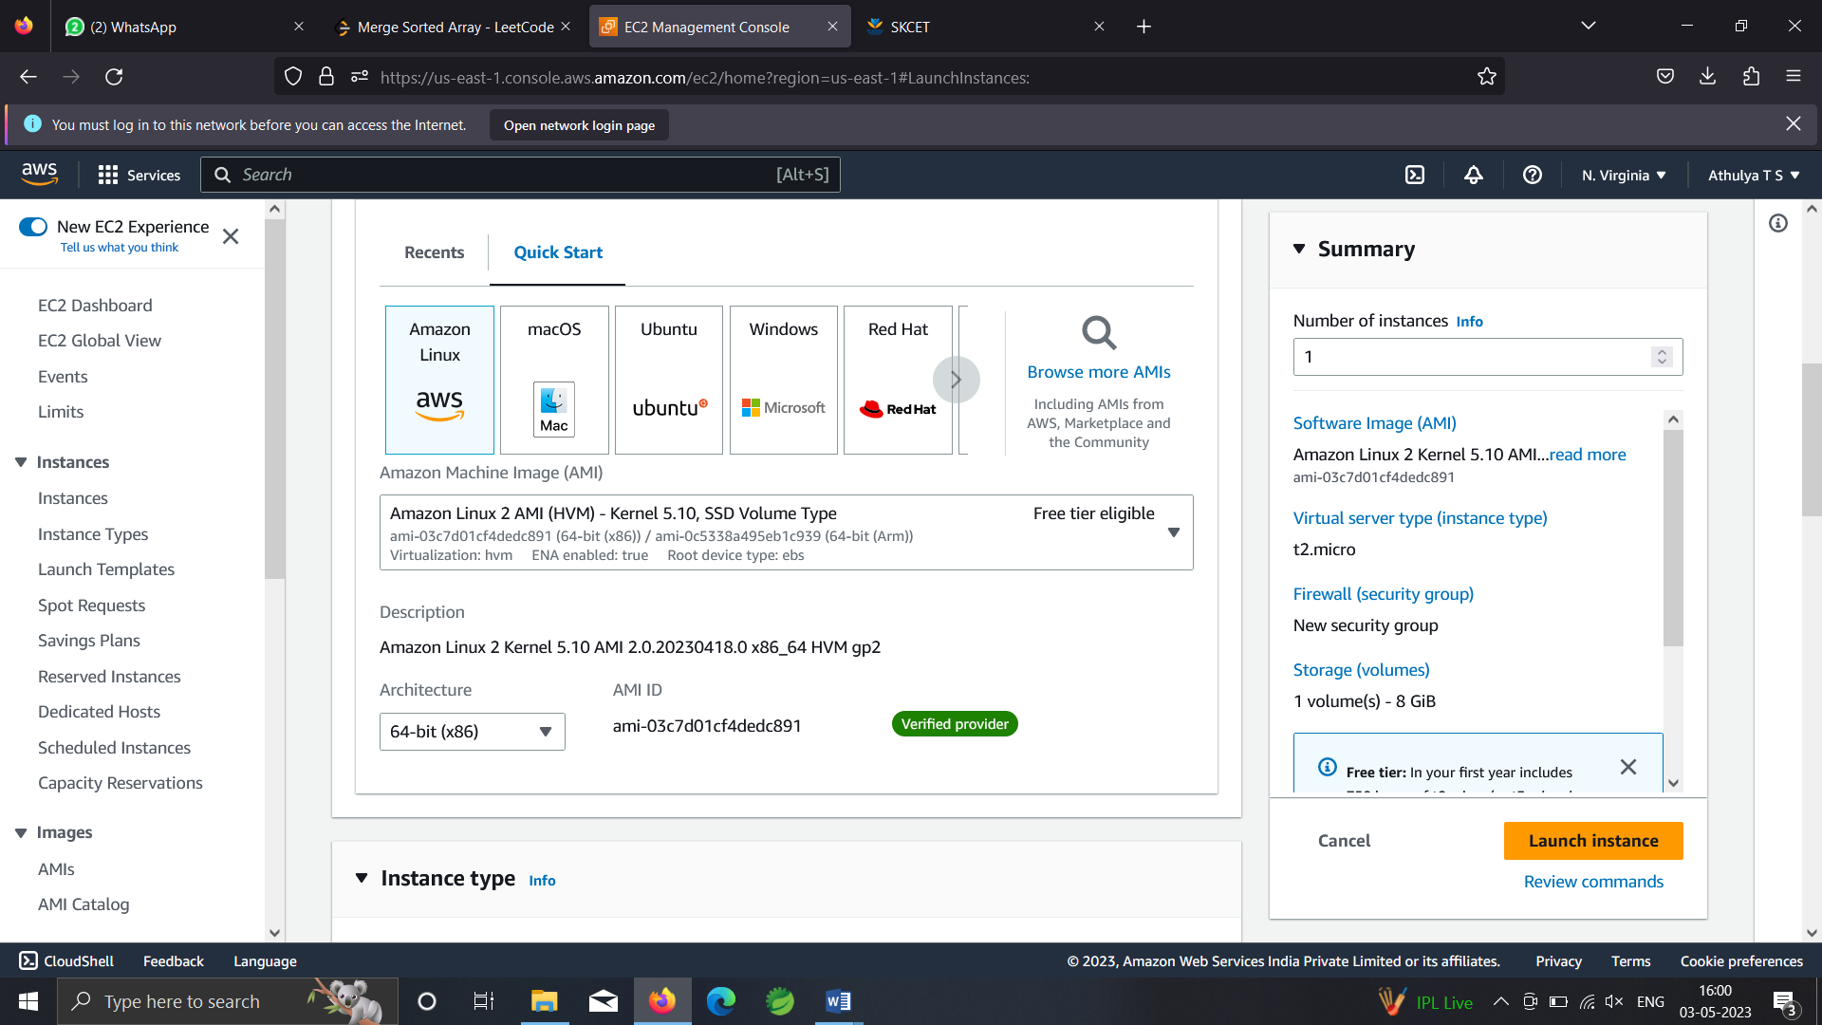

Allow ssh

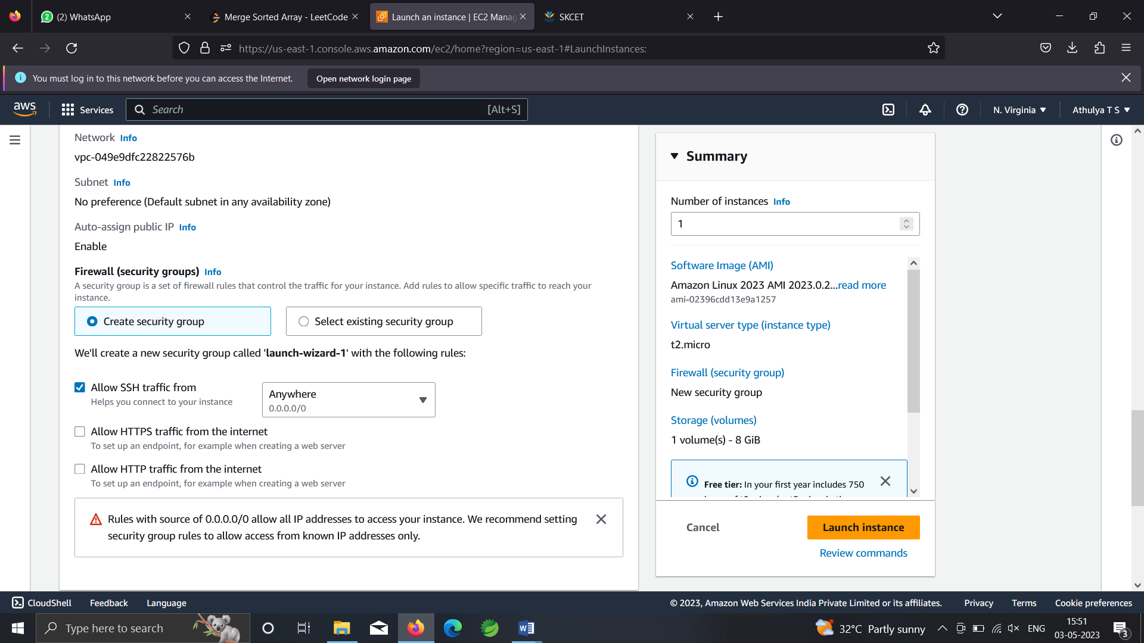

Allow HTTP

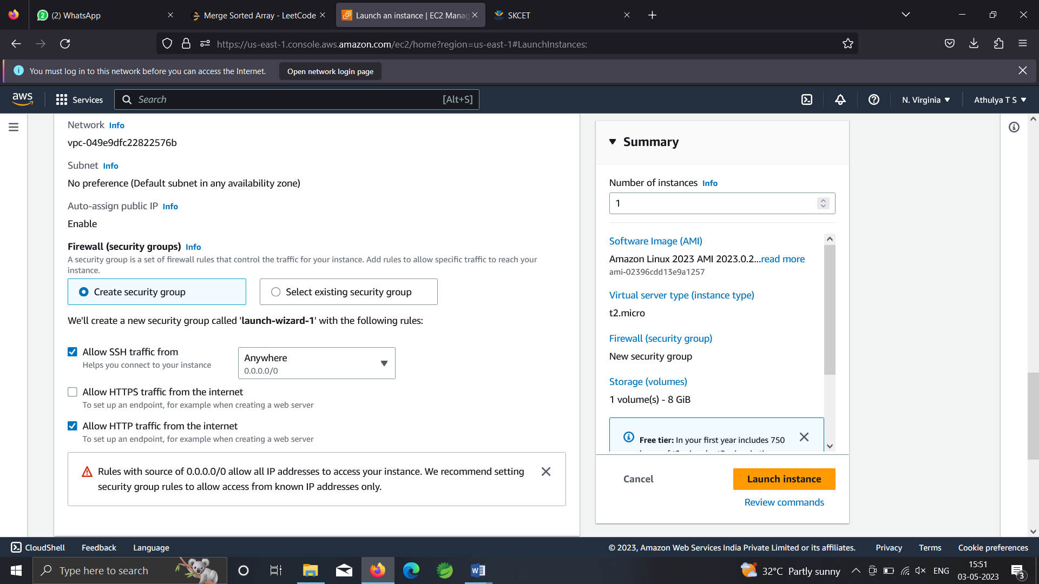

Launch instance



Q.2

Iam console🡪create user group

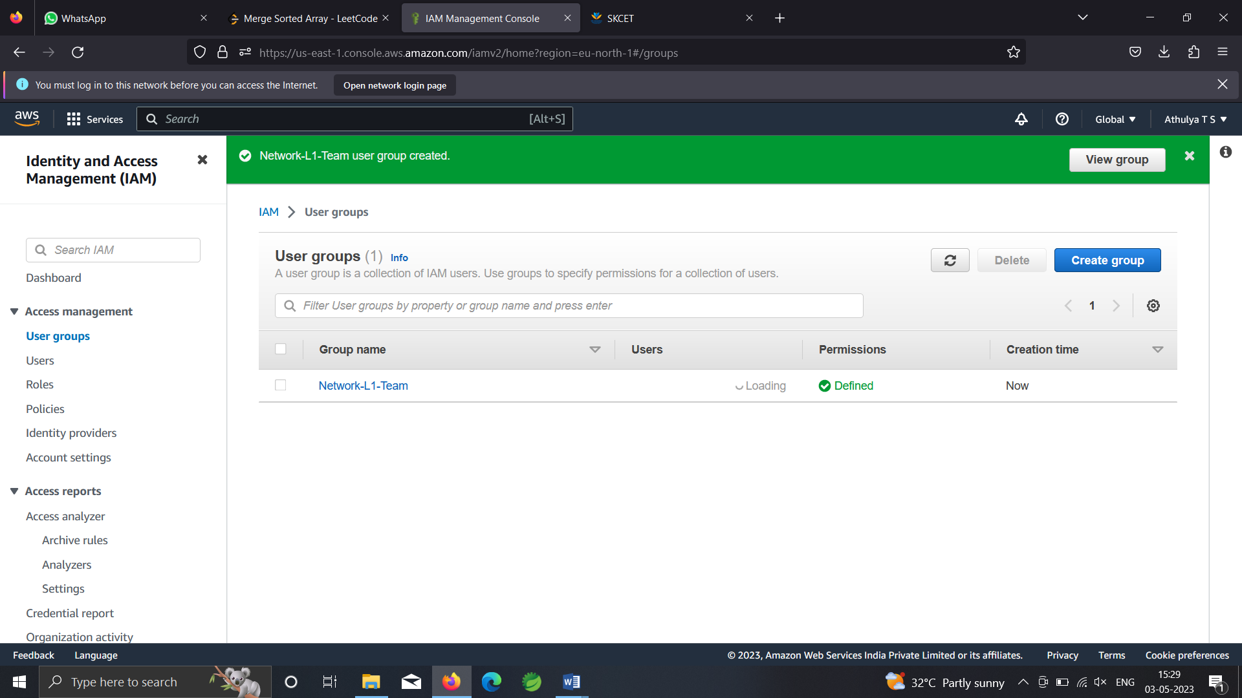

While creating usergroup, attach AmazonVPCReadOnlyAccess

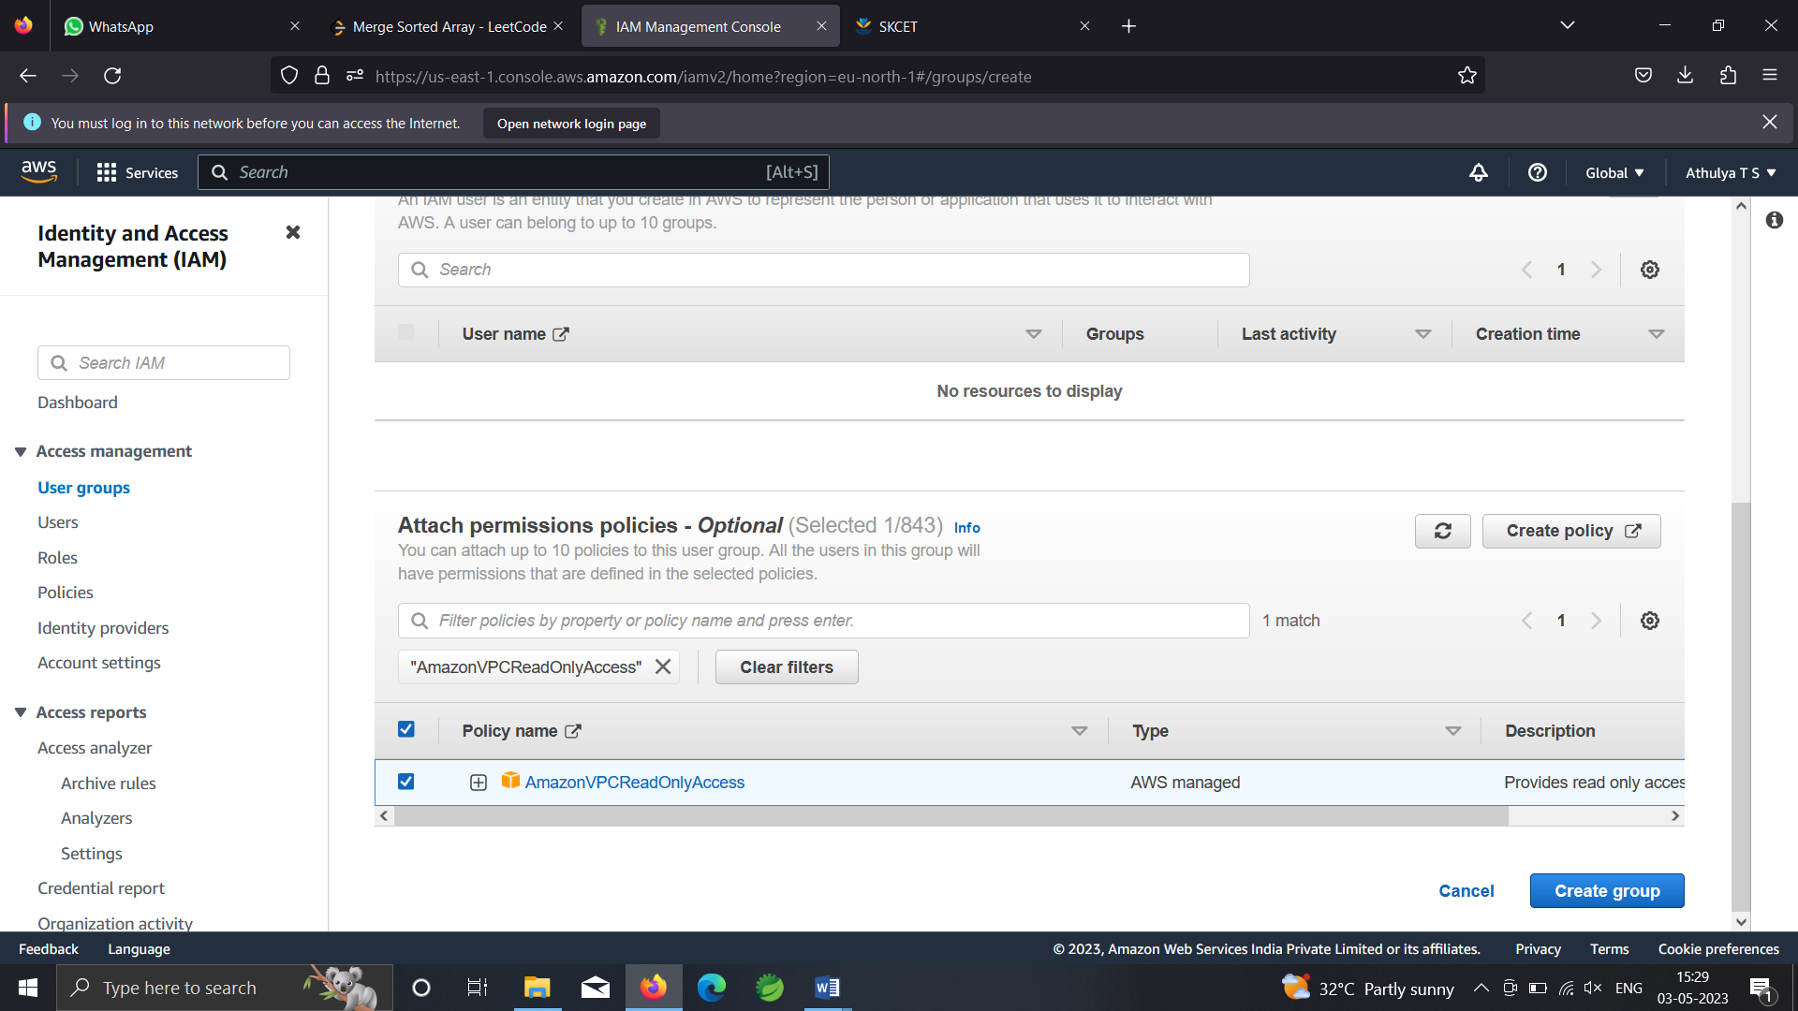

Create user

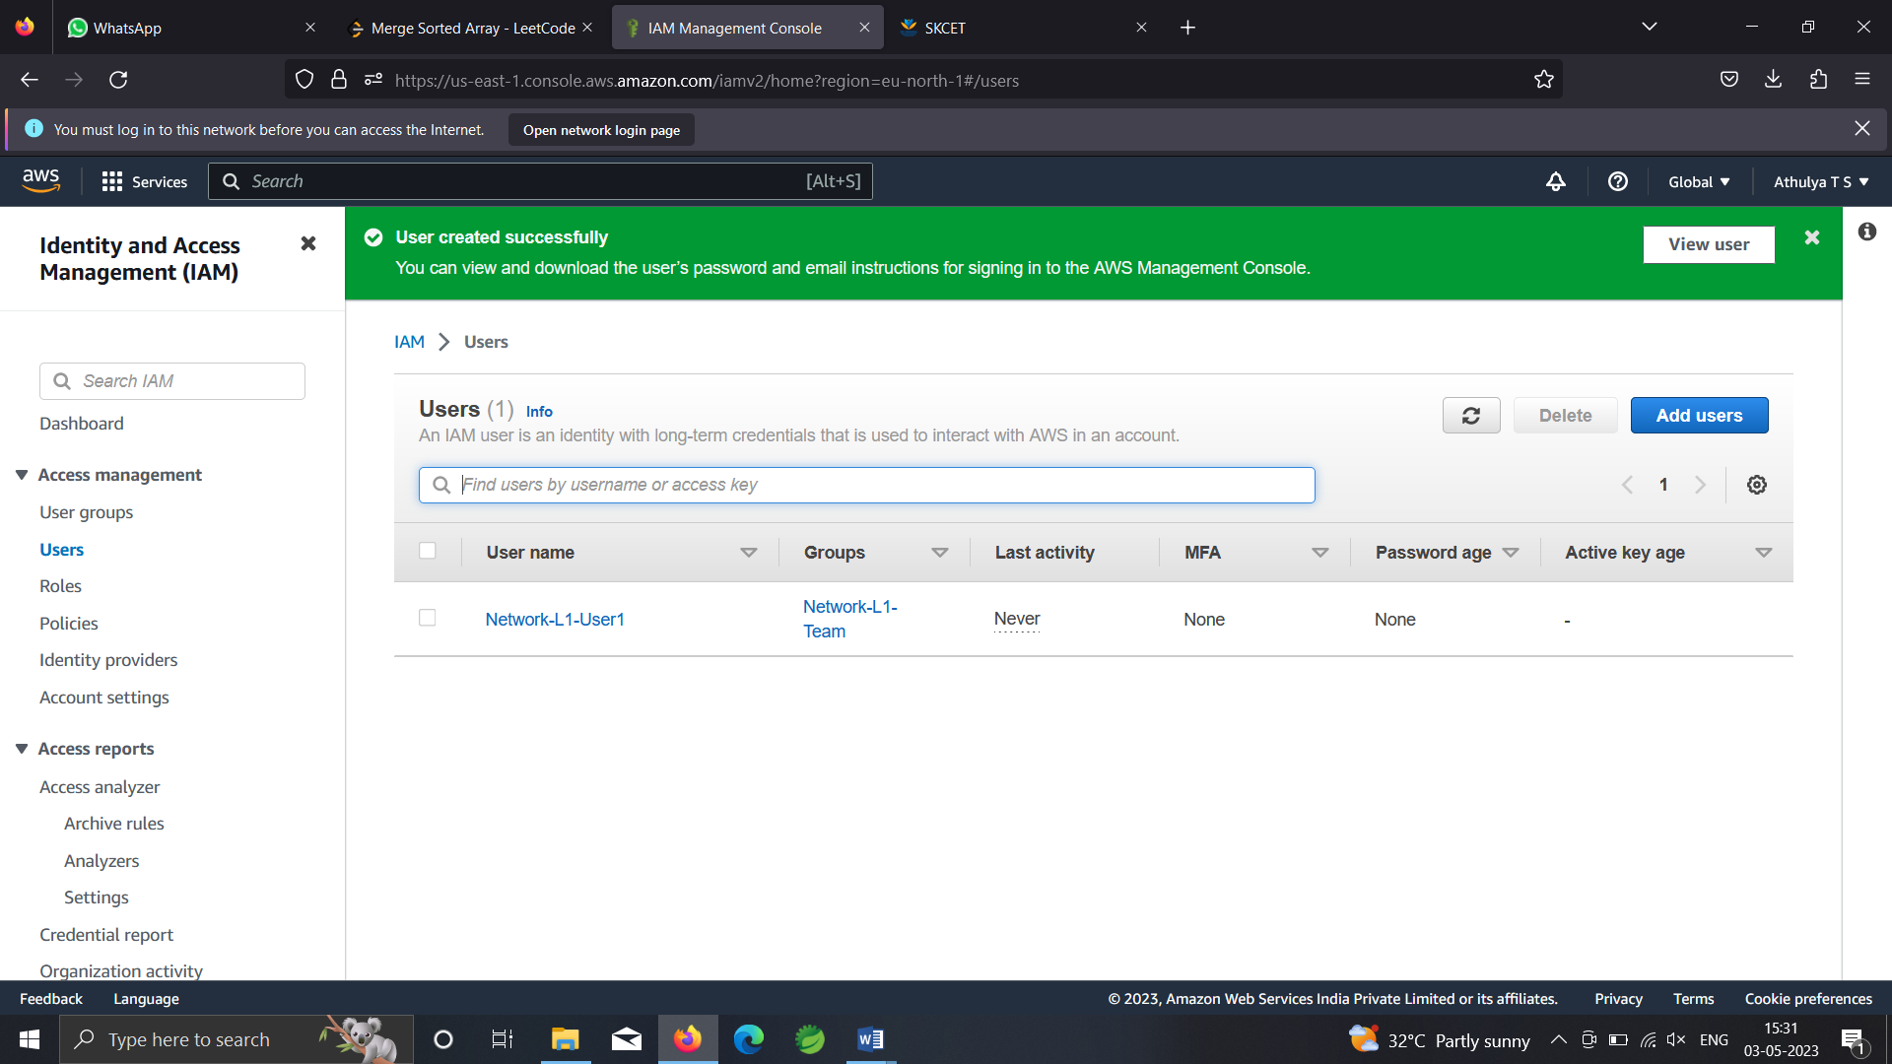

Select the usergroup🡪permissions🡪add permissions🡪attach policy🡪add AWSNetworkManagerReadOnlyAccess

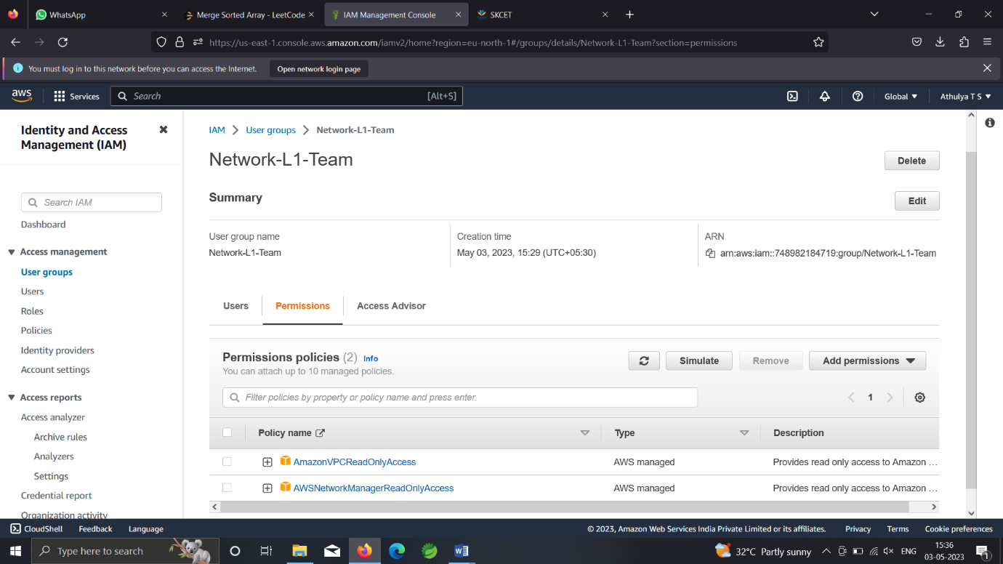

Q.3

S3 console🡪create bucket🡪give name🡪give region as Stockholm🡪create

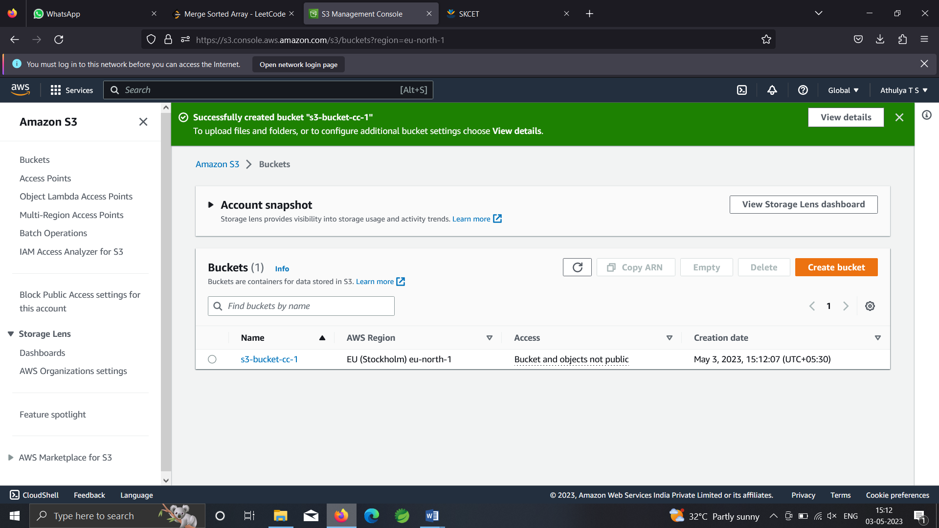

Upload a text file with the name accounts.txt within the bucket

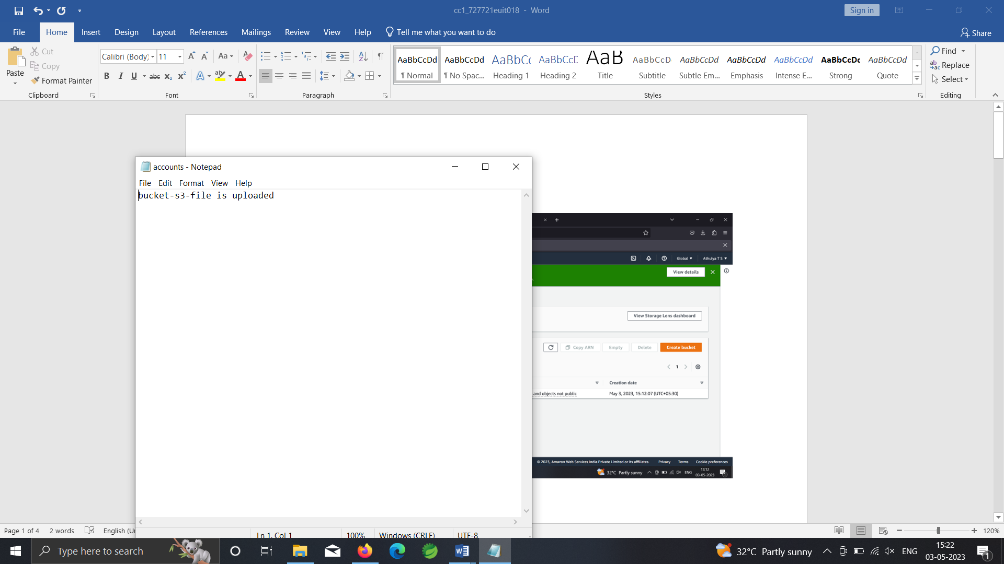

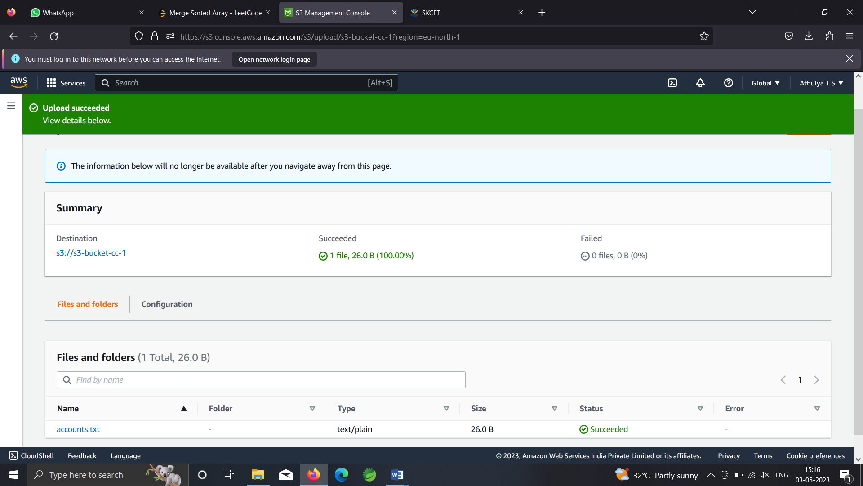

Disable block public access within bucket level permissions

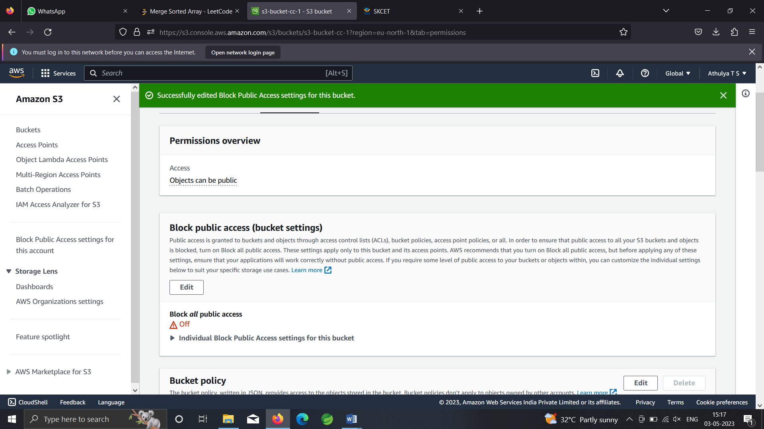

Enable acl within object ownership

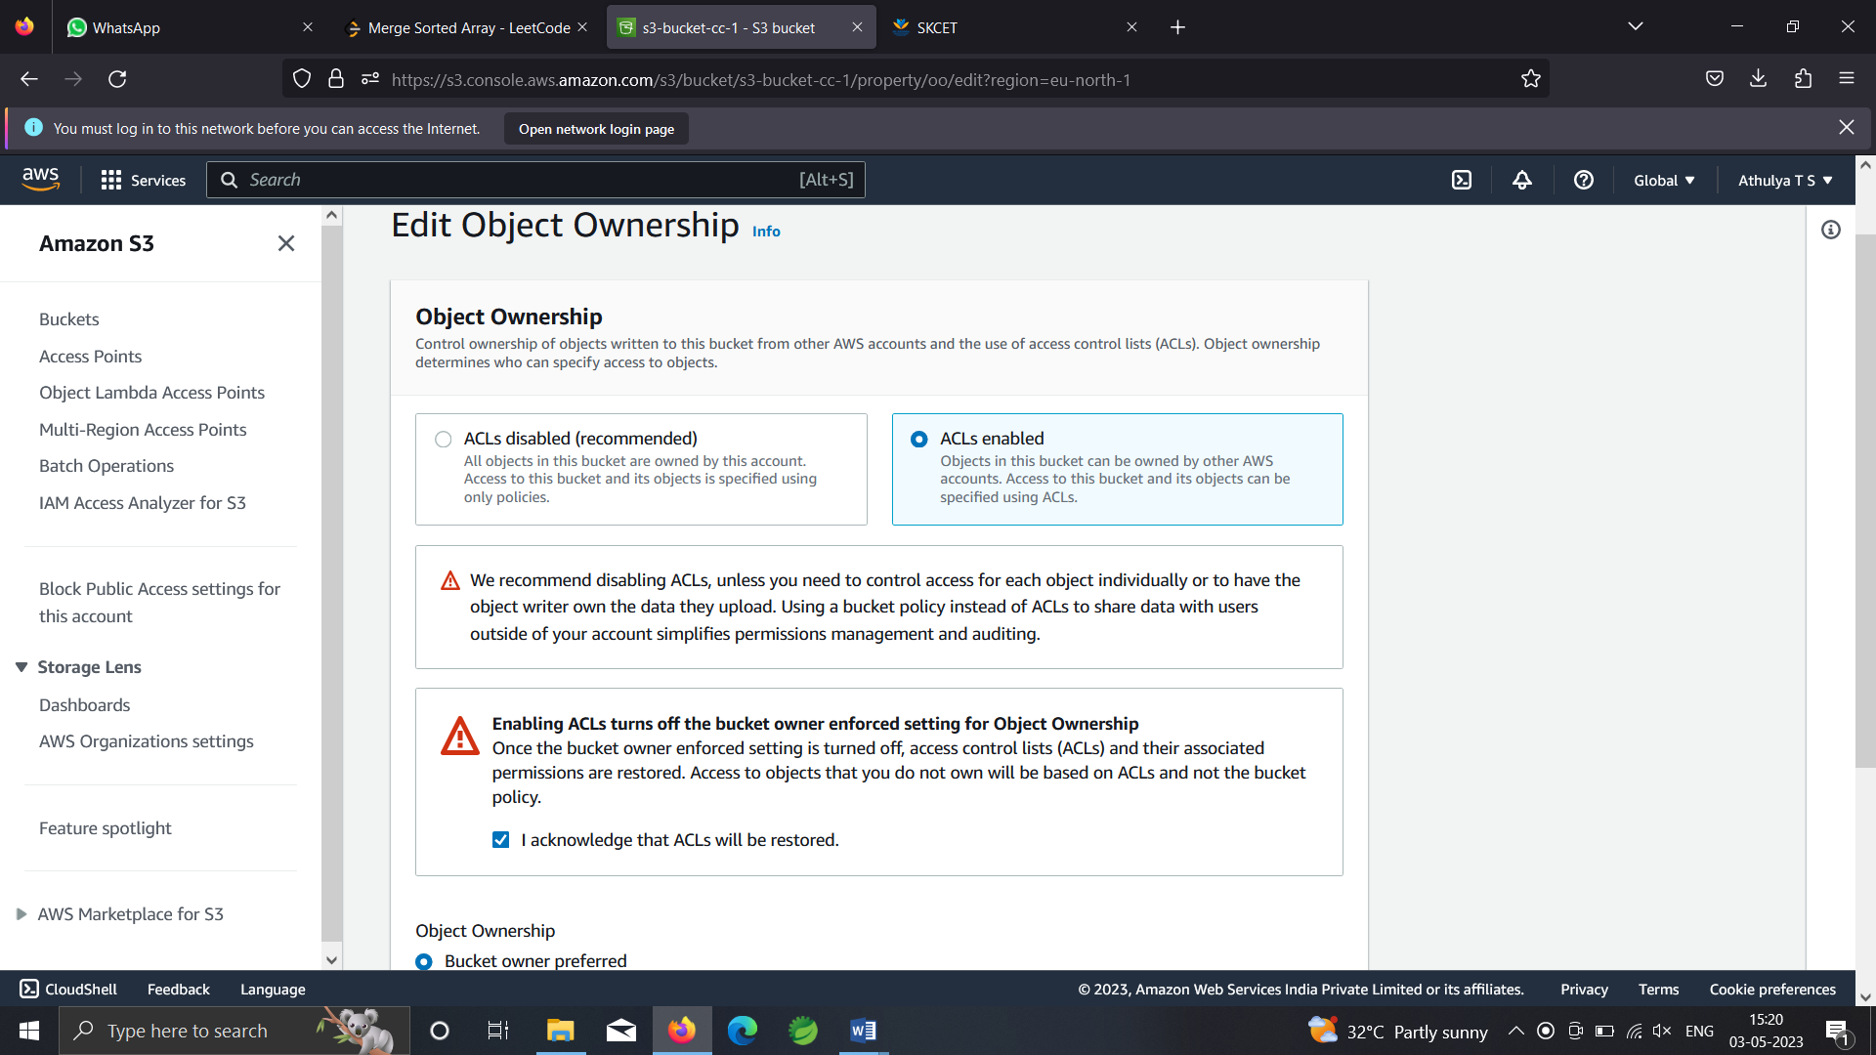

Edit object level acl

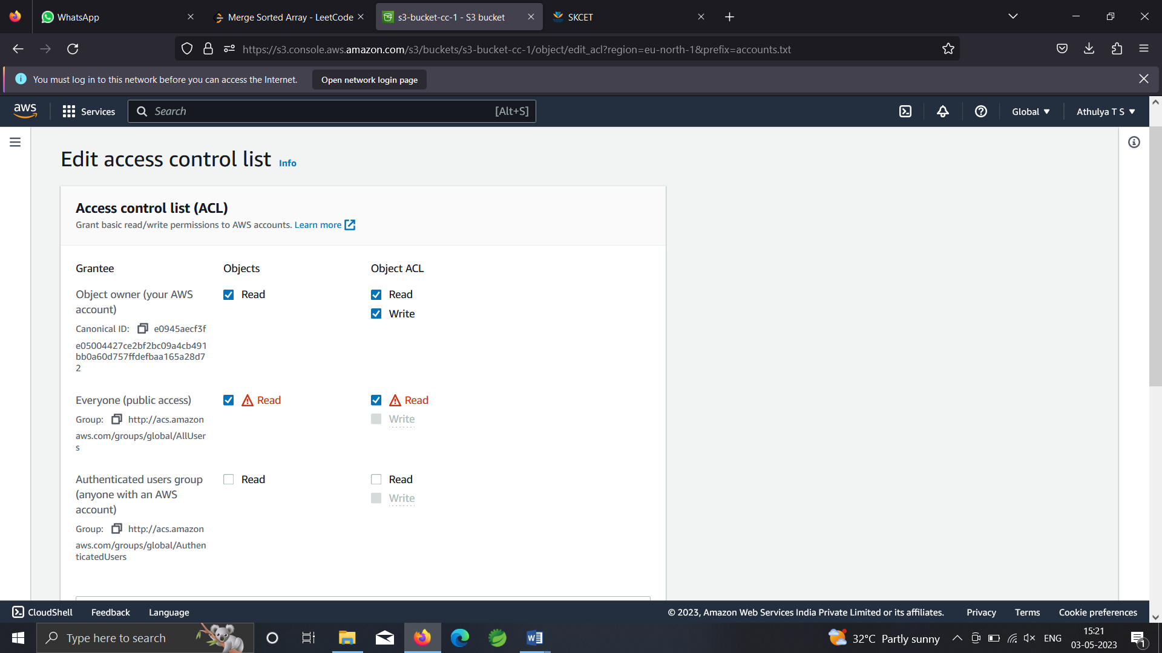

Click on object url

Output

